# ProgressReport

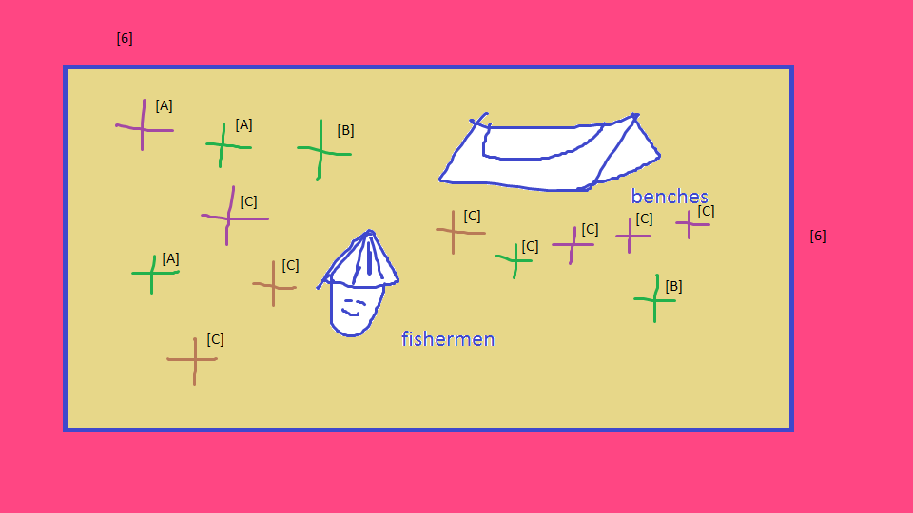

# [LevelsIndicater]

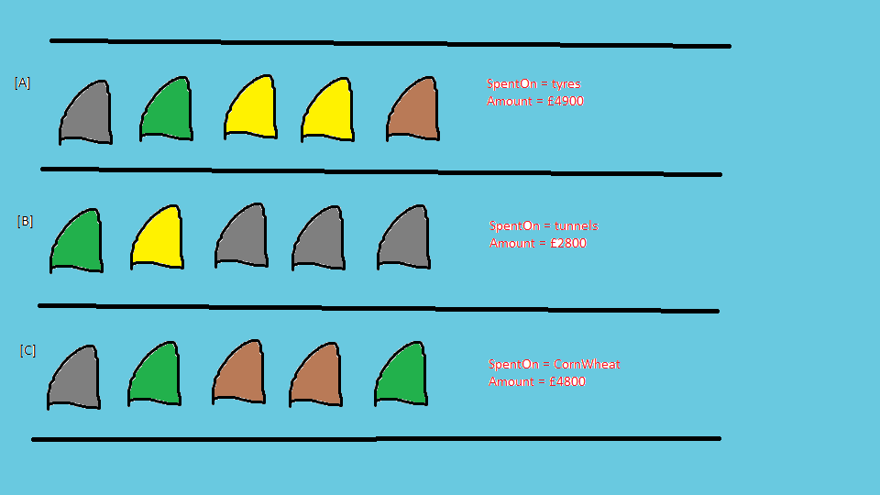

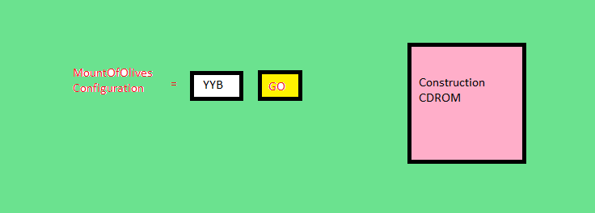

# ConstructionCDROM

## *NETCore*

* Introduction = comprising
* ActualEmbedment = desertwide
* Picture = 
* Columns = 
* [Edit] = 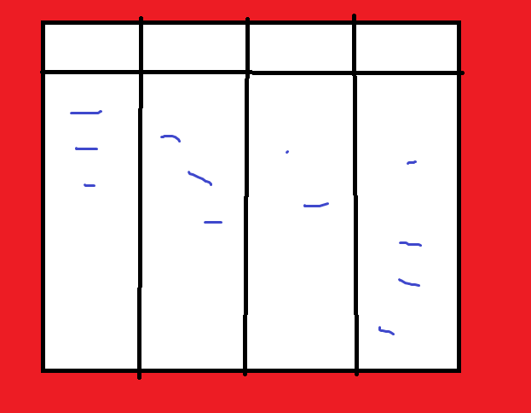

## *NETStandard*

* Introduction = crystalline
* ActualEmbedment = depeche
* Picture = 
* Columns = 
* [Edit] = 